

**DEPARTMENT OF COMPUTER SCIENCE AND DESIGN ACADEMIC YEAR 2024-2025 ODD SEMESTER**



**CD23332 LAB MANUAL SECOND YEAR**

**THIRD SEMESTER 2024- 2025**

**ODD SEMESTER**

RAJALAKSHMI ENGINEERING COLLEGE

**RAJALAKSHMI NAGAR, THANDALAM – 602 105**



|  |  |
| --- | --- |
| **CD23331**  **DESIGN PROCESSES AND PERSPECTIVES LABORATORY** |  |
| **Laboratory Manual Note Book** |

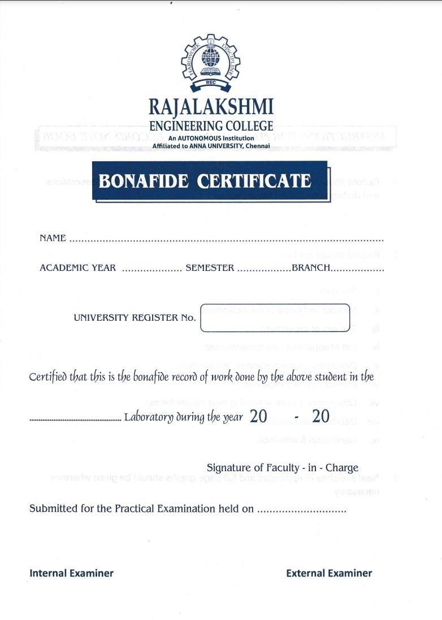

**List of Experiments**

|  |  |  |
| --- | --- | --- |
| 1 | Design to teach mathematics to the children of 4-5 years age in school in Rural sector | |
| 2 | Design to help people to sell their handmade products in metro cities | |
| 3 | Design a social media website and chat | |
| 4 | Design a publication that support different languages | |
| 5 | Design a publication that tells comic stories | |
| 6 | Design an advertisement for mobile company | |
| 7 | Design an advertisement for any political party with images | |
| 8 | Design an advertisement for electronic products | |
| 9 | Design an advertisement for food products | |
| 10 | Design an interactive website for new institution | |
| 11 | Design a blog that publish educational post | |
| 12 | Design an interactive website for hospital management system | |
| 13 | Design an interactive website for food selling app | |
| **Requirements** | | |
| Hardware | | Intel i3 or AMD processor with 64-bit support;2 GHz or faster processor with SSE 4. or later- 8 GB RAM -Windows 10 64-it (version 1909)or later - 1.5 GB of GPU memory -4 GB of available hard-disk space |
| Software | | Figma, Adobe Photoshop, HTML and CSS |
| Operating System | | Windows |

## LAB PLAN

**CD23332-DESIGN PROCESSES AND PERSPECTIVES LAB**

|  |  |  |
| --- | --- | --- |
| **Exercise no.** | **Exercise Name** | **Required Hours** |
| 1 | Design to teach mathematics to the children of 4-5 years age in school in Rural sector | 3 |
| 2 | Design to help people to sell their handmade products in metro cities | 6 |
| 3 | Design a social media website and chat | 3 |
| 4 | Design a publication that support different languages | 3 |
| 5 | Design a publication that tells comic stories | 3 |
| 6 | Design an advertisement for mobile company | 3 |
| 7 | Design an advertisement for any political party with images | 9 |
| 8 | Design an advertisement for electronic products | 6 |
| 9 | Design an advertisement for food products | 6 |
| 10 | Design an interactive website for new institution | 6 |
| 11 | Design a blog that publish educational post | 6 |
| 12 | Design an interactive website for hospital management system. | 3 |
| 13 | Design an interactive website for food selling app. | 3 |

**Course Outcomes (COs)**

**Course Name: Design Processes and Perspectives Course Code: CD19341**

|  |  |
| --- | --- |
| Outcome 1 | Understand the various graphic design thinking process and phases |
| Outcome 2 | Analyze and choose between various visual components |
| Outcome 3 | Designing and communicating visual components |
| Outcome 4 | Apply design concepts for media publishing and advertising |
| Outcome 5 | Create website using different design concepts |

CO-PO –PSO matricesofcourse

|  |  |  |  |  |  |  |  |  |  |  |  |  |  |  |  |
| --- | --- | --- | --- | --- | --- | --- | --- | --- | --- | --- | --- | --- | --- | --- | --- |
| PO/PSO  CO | PO 1 | PO 2 | PO 3 | PO 4 | PO 5 | PO 6 | PO 7 | PO 8 | PO 9 | PO 10 | PO 11 | PO 12 | PSO 1 | PSO 2 | PSO 3 |
| CD19341.1 | 3 | 1 | 3 | 2 | 3 | 2 | 3 | 2 | 1 | 1 | 1 | 3 | 1 | 3 | 1 |
| CD19341.2 | 3 | - | 3 | - | 3 | - | - | - | - | - | 1 | 1 | 1 | 3 | 1 |
| CD19341.3 | 3 | 3 | 3 | 2 | 3 | - | - | - | - | - | - | 1 | 1 | 3 | 2 |
| CD19341.4 | 1 | 3 | 3 | 3 | 3 | 3 | 2 | 2 | 2 | 2 | 2 | 2 | 1 | 3 | 3 |
| CD19341.5 | 1 | 3 | 3 | 3 | 3 | 3 | 2 | 2 | 2 | 2 | 2 | 2 | 1 | 3 | 3 |
| Average | 2.2 | 2.0 | 3.0 | 2.0 | 3.0 | 1.6 | 1.4 | 1.0 | 1.0 | 1.0 | 1.2 | 1.8 | 1.0 | 3.0 | 2.0 |

Note: Enter correlation levels 1,2 or 3 as defined below:

1: Slight(Low) 2: Moderate(Medium) 3: Substantial(High) If there is no correlation, put “-“

**Expt. No.:1 Date:**

# Design to teach mathematics to the children of 4-5 years age in school in Rural sector

**Aim:** To design a user interface for teaching mathematics to the children of 4-5 years age in school in the rural sector.

**Tools:** Figma, Photoshop

## Steps:

1. Create a new background layer.
2. Create containers for placing images, icons and logos.
3. Gradient color panel has to be used.
4. Buttons and attractive fonts have been used.
5. Proper navigation should be done to move from one page to another.
6. Login page has to be included.

## Output:

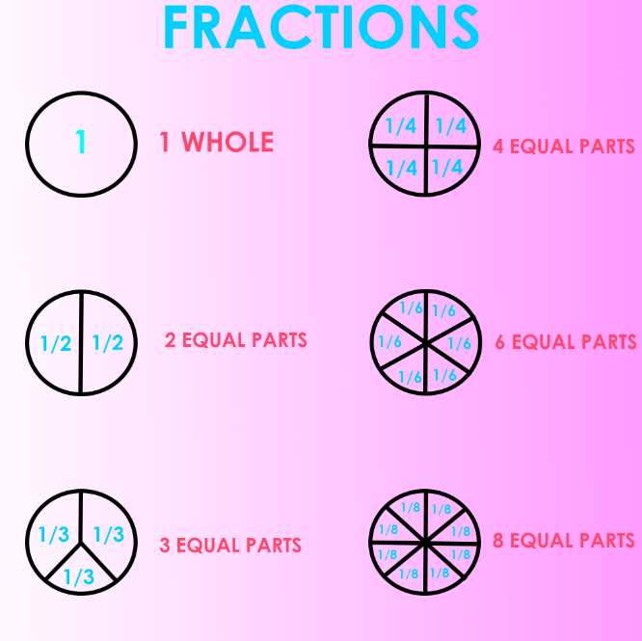

**Result:** Hence the design is completed and output is verified.

## Expt. No.:2 Date:

**Design to help people to sell their handmade products in metro cities**

**AIM:** To Design an UI that can help people to sell their handmade products in metro cities

**Tools:** Figma, Photoshop

## Steps:

1. Create a new background layer.
2. Create containers for placing images, icons and logos.
3. Gradient color panel has to be used.
4. Buttons and attractive fonts have been used.
5. Proper navigation should be done to move from one page to another.
6. Login page has to be included.

## Output:

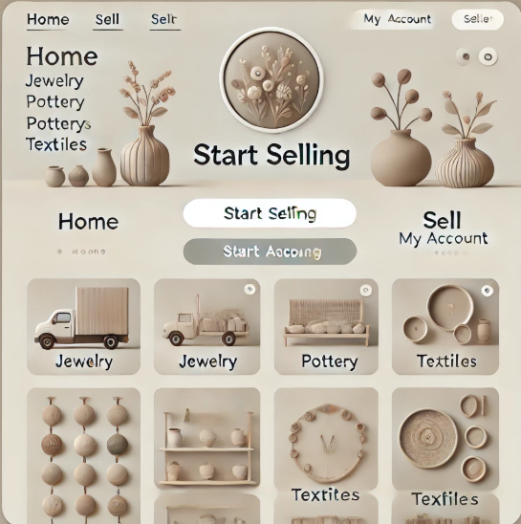

**Result:** Hence the design is completed and output is verified.

**Expt. No.:3 Date:**

# Design a social media website and chat

**Aim:** To design a social media website and chat.

**Tools:** Figma, Photoshop

## Steps:

1. Create a new background layer.
2. Create containers for placing images, icons and logos
3. Gradient color panel has to be used
4. Buttons and attractive fonts have been used
5. Proper navigation should be done to move from one page to another
6. Login page has to be included

## Output:

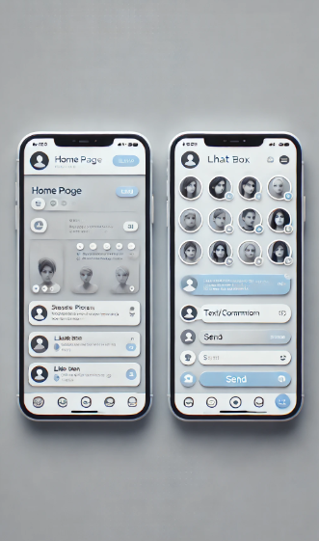

**Result:** Hence the design is completed and output is verified.

**Expt. No.:4 Date:**

# Design a publication that support different languages

**Aim:** To design a publication that support different language

**Tools:** Adobe Photoshop

## Steps:

1. Create a new background layer.
2. Create containers for placing images, icons and logos
3. Gradient color panel has to be used
4. Use different languages to display the content.
5. Use images that support the content.
6. Align white spaces between the contents.

## Output:

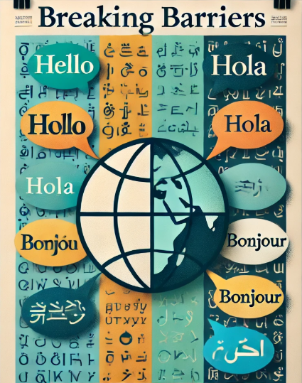

**Result:** Hence the design is completed and output is verified.

## Expt. No.:5 Date:

**Design a publication that tells comic stories**

**Aim:** To design a Publication That Tells Comic Stories

**Tools:** Adobe Photoshop

## Steps:

1. Create a new background layer.
2. Create containers for placing images, icons and logos
3. Gradient color panel has to be used.
4. Use different languages to display the content.
5. Use images that support the content.
6. Align white spaces between the contents.

## Output:



**Result:** Hence the design is completed and output is verified.

**Expt. No.:6 Date:**

# Design an advertisement for mobile company

**Aim:** To design an advertisement for mobile company

**Tools:** Adobe Photoshop, Canva

## Steps:

1. Create a new background layer.
2. Create containers for placing images, icons and logos
3. Gradient color panel has to be used
4. Images that support the context must be placed.
5. Written context must be emphasized.
6. Appropriate color palette must be used.

## Output:



**Result:** Hence the design is completed and output is verified.

**Expt. No.:7 Date:**

# Design an advertisement for any political party with images

**Aim:** To design an advertisement for any political party with images

**Tools:** Adobe Photoshop, Canva.

## Steps:

1. Create a new background layer.
2. Create containers for placing images, icons and logos.
3. Gradient color panel has to be used.
4. Images that support the context must be placed.
5. Written context must be emphasized.
6. Appropriate color palette must be used.

## Output:



**Result:** Hence the design is completed and output is verified.

## Expt. No.:8

**Date:**

# Design an advertisement for electronic products

**Aim:** To design an advertisement for electronic products

**Tools:** Adobe Photoshop, Canva

## Steps:

1. Create a new background layer.
2. Create containers for placing images, icons and logos.
3. Gradient color panel has to be used .
4. Images that support the context must be placed.
5. Written context must be emphasized.
6. Appropriate color palette must be used.

## Output:

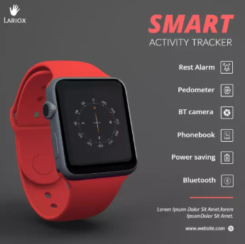

**Result:** Hence the design is completed and output is verified.

**Expt. No.:9 Date:**

# Design an advertisement for food products

**Aim:** To design an advertisement for food products

**Tools:** Adobe Photoshop, Canva

## Steps:

1. Create a new background layer.
2. Create containers for placing images, icons and logos.
3. Gradient color panel has to be used .
4. Images that support the context must be placed.
5. Written context must be emphasized.
6. Appropriate color palette must be used.

## Output:

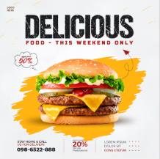

**Result:** Hence the design is completed and output is verified.

**Expt. No.:10 Date:**

# Design an interactive website for new institution

**Aim:** To design interactive website for new institution

**Tools:** HTML, CSS

## Steps:

* 1. Create a document of type HTML.
  2. Craft a style sheet for better design.
  3. Include the link of the stylesheet to the HTML file.
  4. Assign a title for each page.
  5. Add the required styles and attributes for the HTML tags.
  6. Include action tag to navigate from one page to another.

## Output:

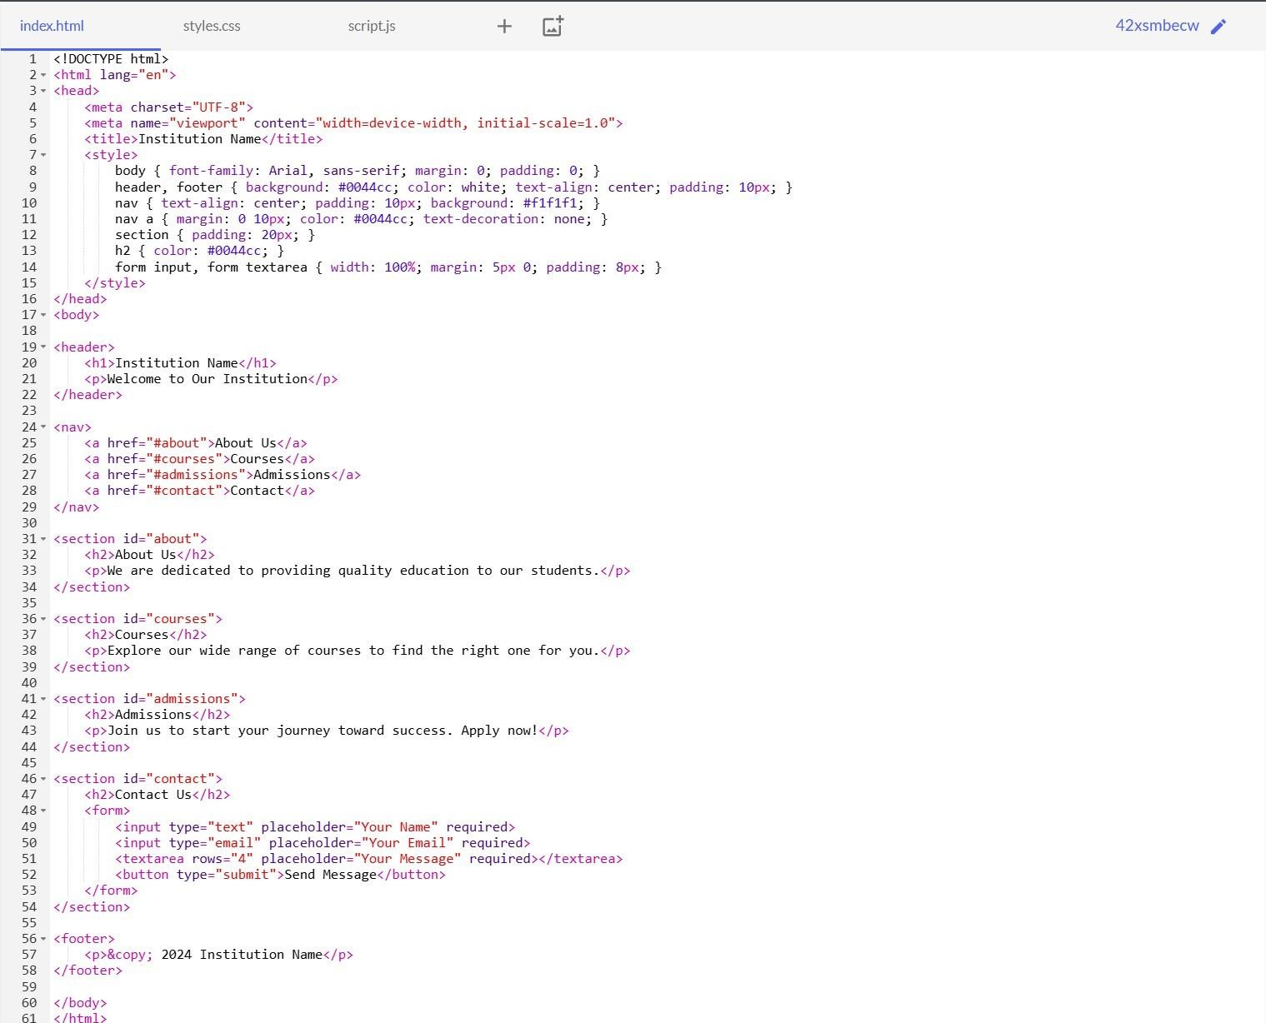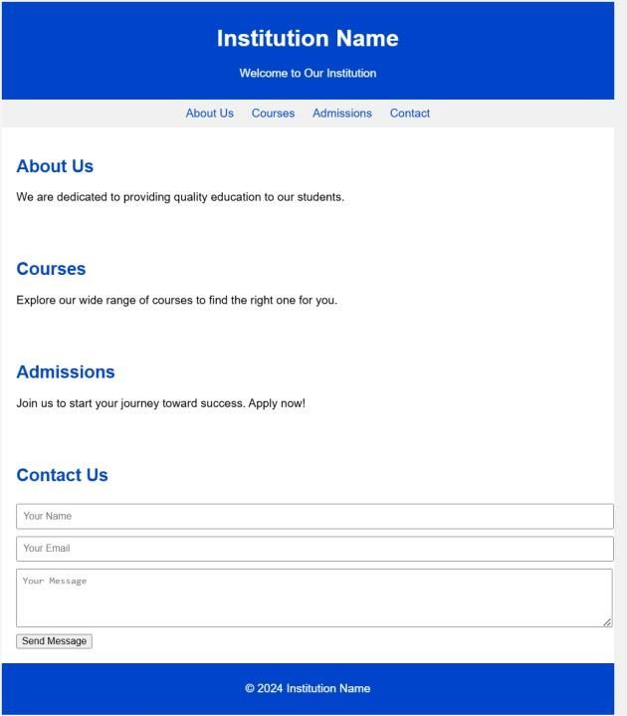

**Result:** Hence the design is completed and output is verified.

**Expt. No.:11 Date:**

# Design A Blog That Publish Educational Post

**Aim:** To design a blog that publishes educational post

**Tools:** HTML, CSS

## Steps:

1. Create a document of type HTML.
2. Craft a style sheet for better design.
3. Include the link of the stylesheet to the HTML file.
4. Assign a title for each page.
5. Add the required styles and attributes for the HTML tags.
6. Include action tag to navigate from one page to another.

## Output:

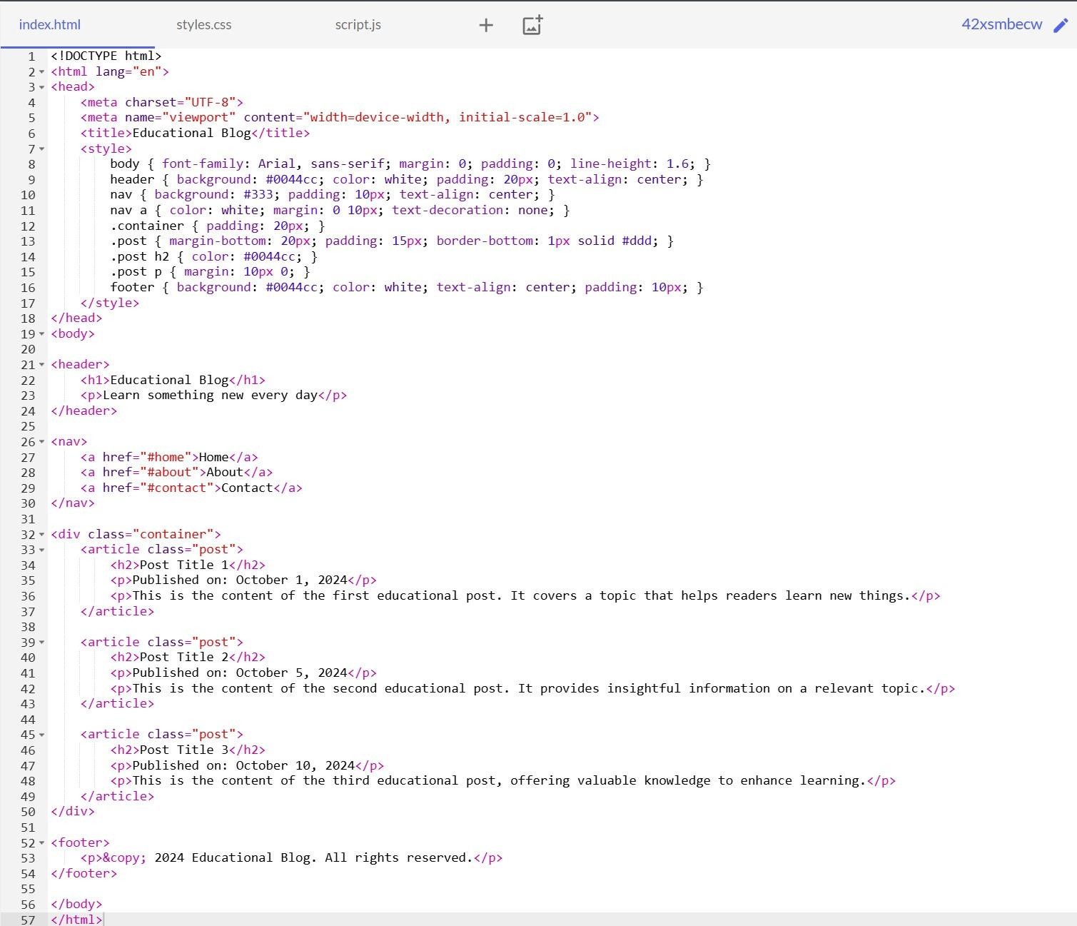

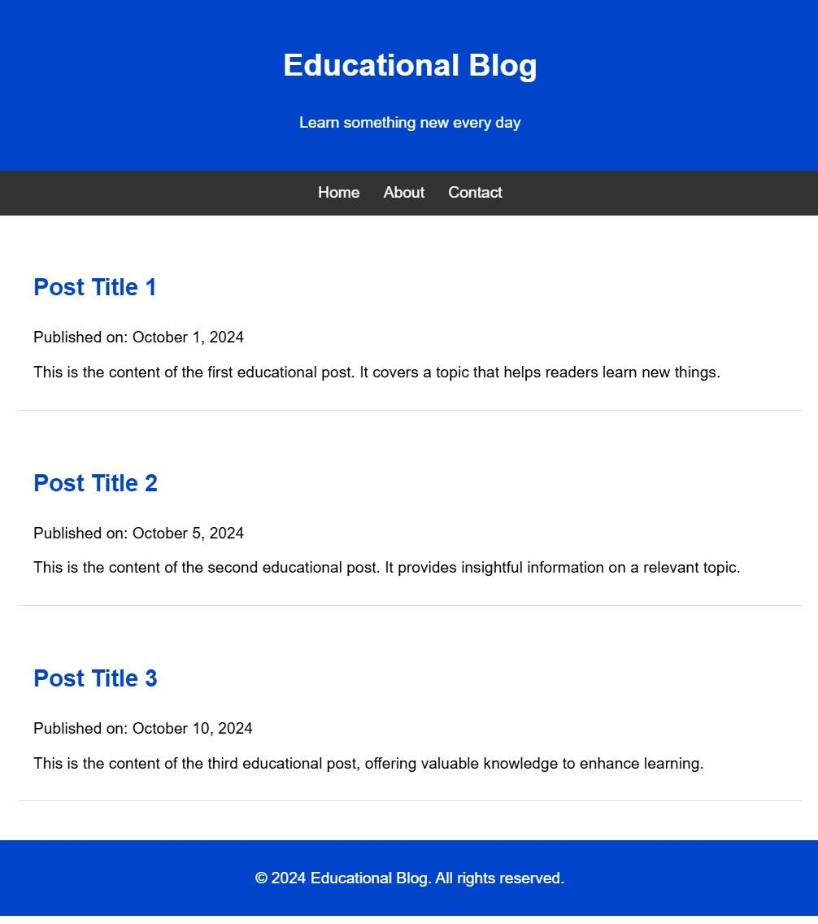

**Result:** Hence the design is completed and output is verified.

**Expt. No.:12 Date:**

# Design An Interactive Website For Hospital Management

**System**

**Aim:** To design interactive website for hospital management system

**Tools:** HTML, CSS

## Steps:

1. Create a document of type HTML.
2. Craft a style sheet for better design.
3. Include the link of the stylesheet to the HTML file.
4. Assign a title for each page.
5. Add the required styles and attributes for the HTML tags.
6. Include action tag to navigate from one page to another.

## Output:

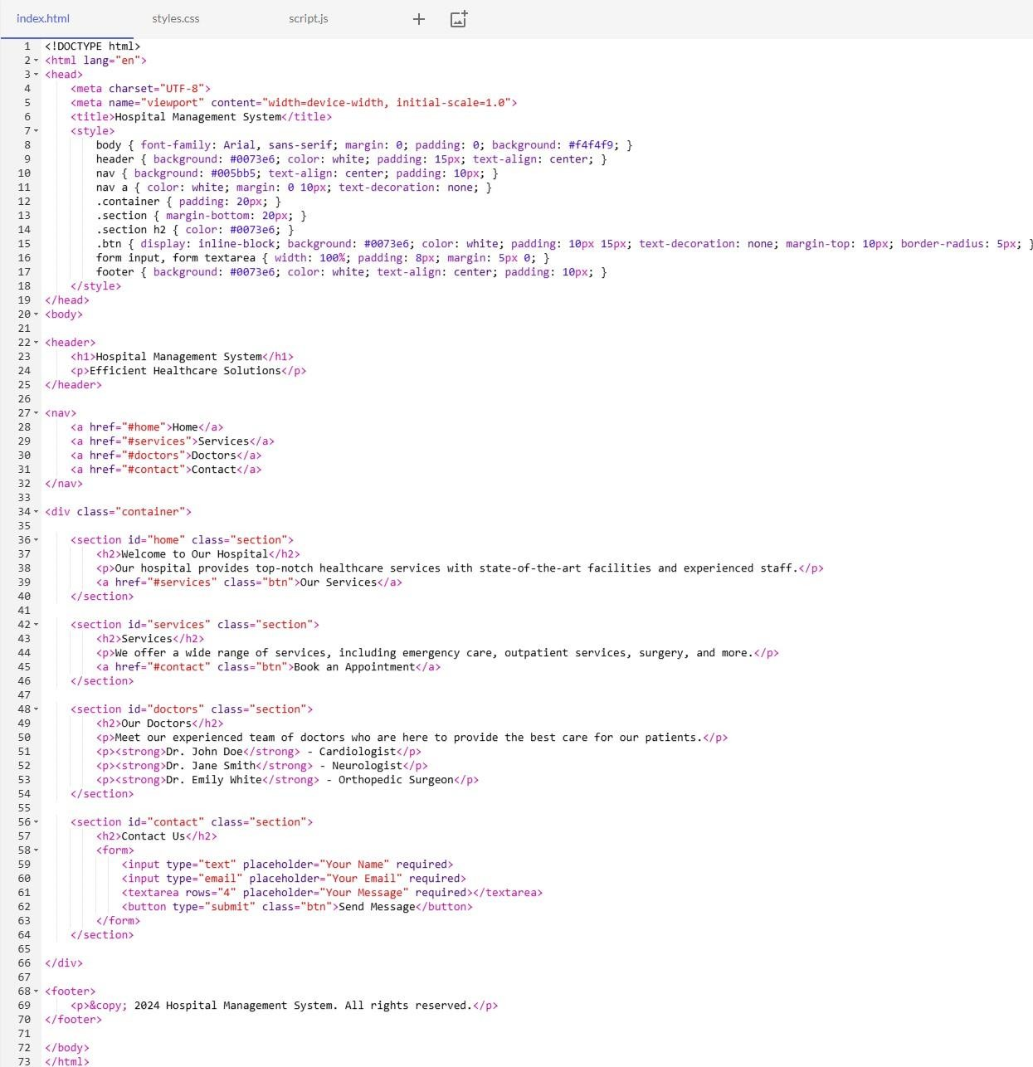

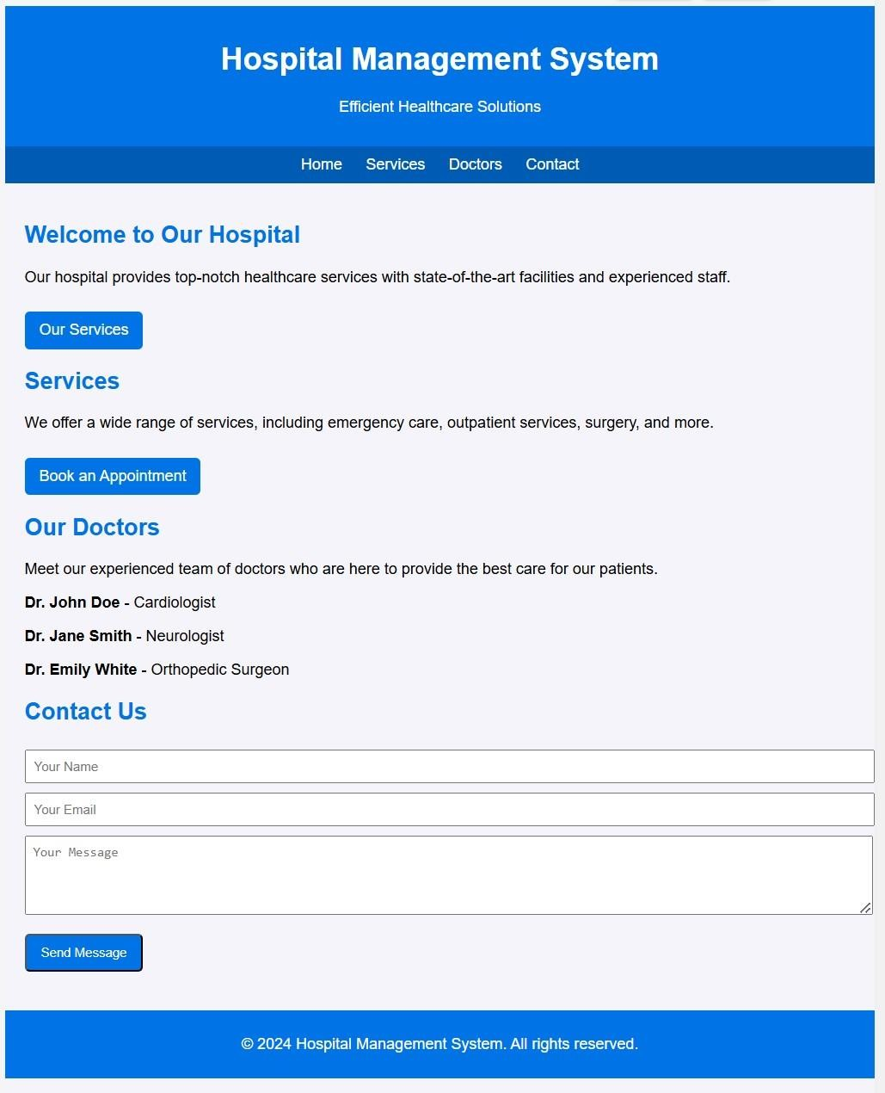

**Result:** Hence the design is completed and output is verified.

**Expt. No.:13 Date:**

# Design An Interactive Website For Food Selling App

**Aim:** To design a interactive website for food selling app

**Tools:** HTML, CSS

## Steps:

1. Create a document of type HTML.
2. Craft a style sheet for better design.
3. Include the link of the stylesheet to the HTML file.
4. Assign a title for each page.
5. Add the required styles and attributes for the HTML tags.
6. Include action tag to navigate from one page to another.

## Output:

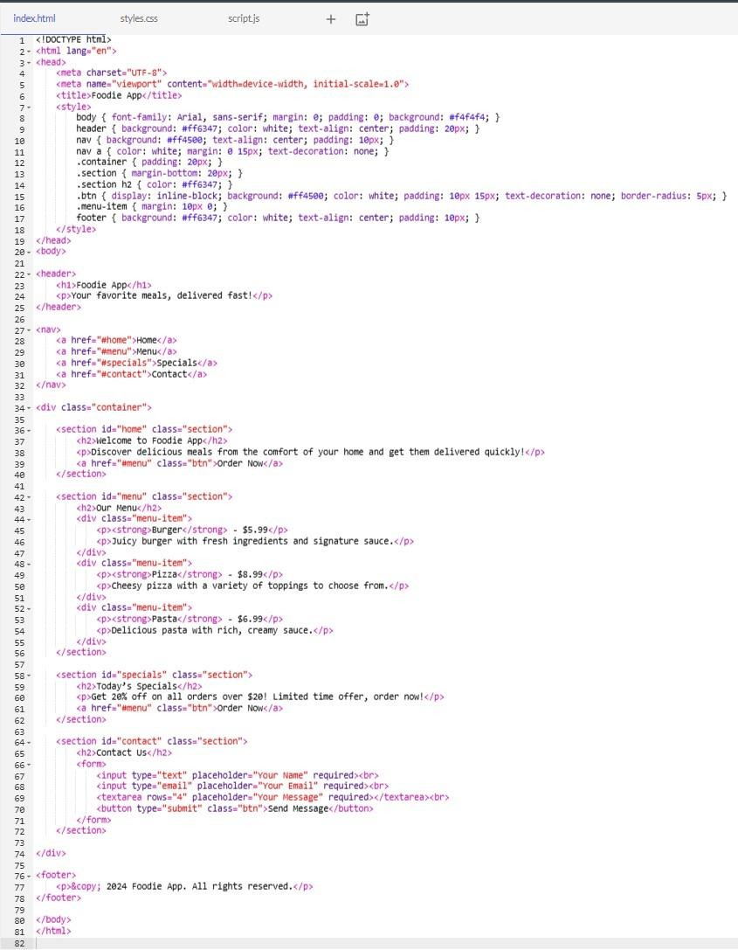

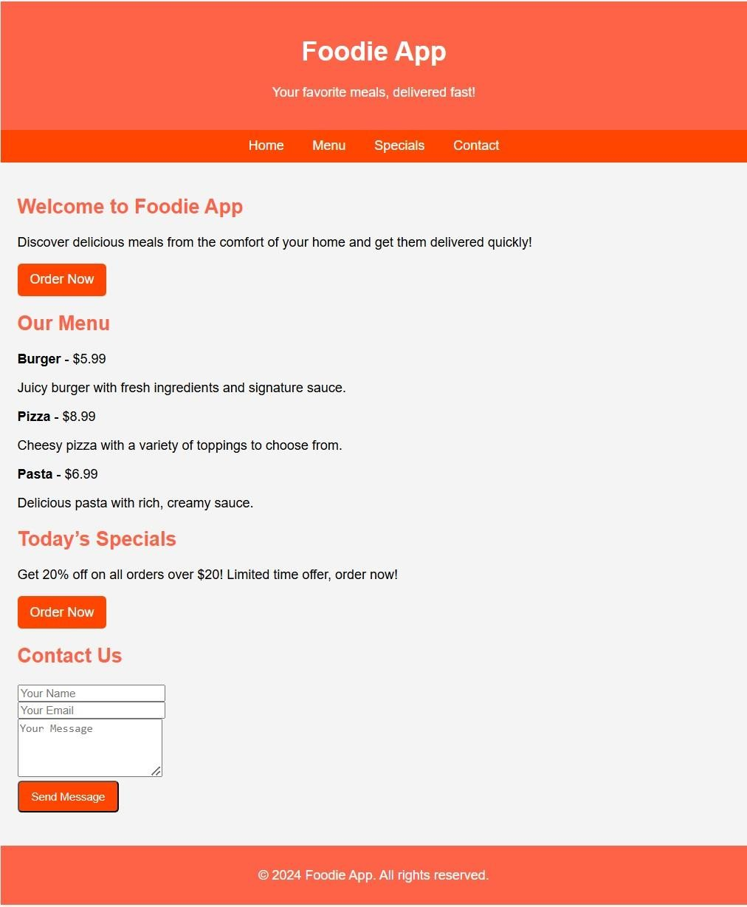

**Result:** Hence the design is completed and output is verified.